NAME: S.PRATIBA
DATE:13.10.25 ROLLNO.:241901080

EXERCISE 15
DEMONSTRATE NETWORK FORENSICS USING PCAPXRAY TOOL
AIM:
To perform network forensics analysis on packet capture (PCAP) files using the PcapXray tool to visualise network traffic, identify devices, detect malicious communication, and extract important network information.
PCAPXRAY TOOL:
PcapXray is a network forensics tool that helps investigators analyze captured network traffic data (PCAP files). It takes raw packet to capture data and converts it into easy-to-understand visual diagrams and reports.
ALGORITHM:
- Install Prerequisites: Install Python 3, Graphviz, and needed Python libraries (Scapy, IPwhois, Netaddr, Stem, pyGraphviz, NetworkX, Pillow, Tkinter).
- Clone Tool: Clone the PcapXray GitHub repository and navigate to its directory.
- Launch PcapXray: Run the tool with elevated privileges (sudo python3 Source/main.py) to open the GUI.
- Load PCAP File: Use the GUI's browse button to select a PCAP file (.pcap or .pcapng).
- Start Analysis: Click the “Analyze” button to begin automated parsing of packets.
- Packet Processing: Tool reads packets with Scapy, extracting IPs, ports, and protocols.
- Lookups & Detection: WHOIS queries run for external IPs; Tor nodes and malicious patterns get identified.
- Generate Visualization: Network graph rendered showing devices as nodes and communications as edges, color-coded by protocol and threat.
- Create Reports: Tool builds reports covering device details, traffic summary, payloads, and flagged suspicious activities.
- Review Results: User views interactive diagrams, filters traffic types, examines reports, and exports findings.

OUTPUT:
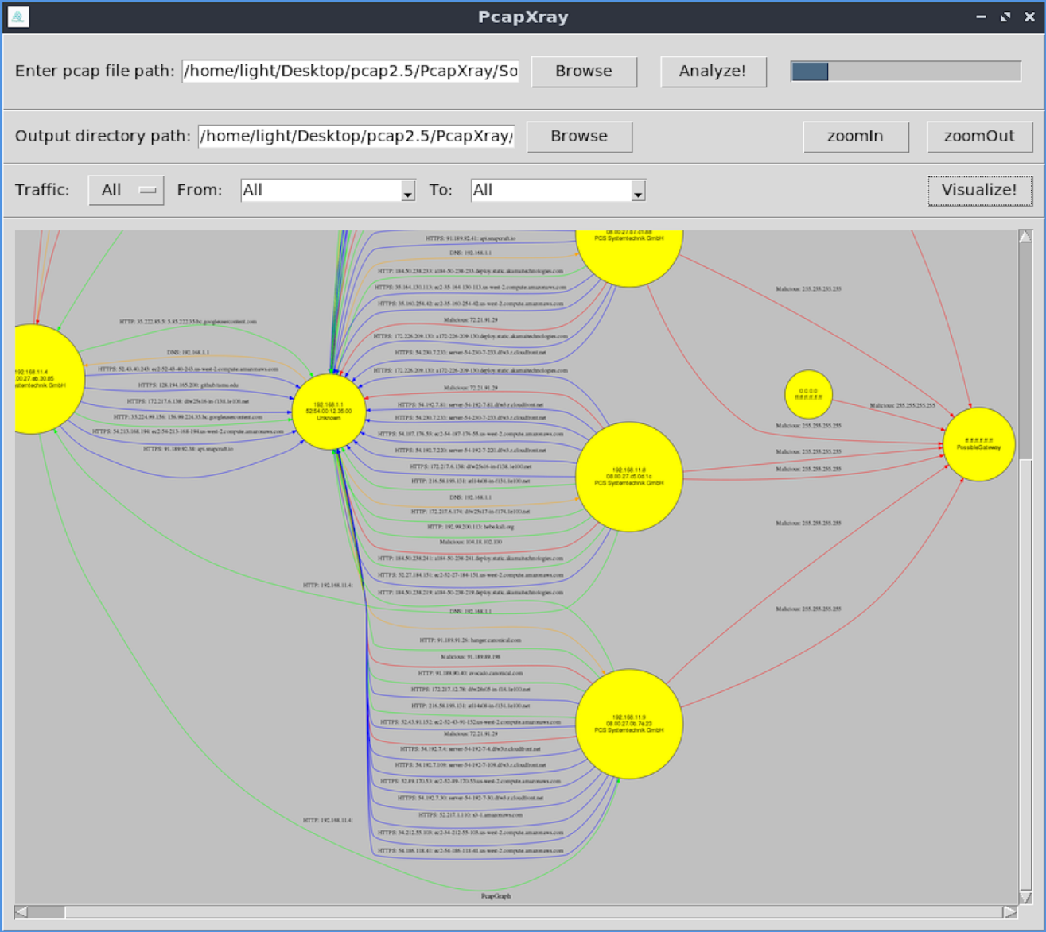PcapXray interface showing a network traffic visualization graph from a pcap file, highlighting IP addresses and potential malware communications


PACKET DETAILS: DEVICE DETAILS:
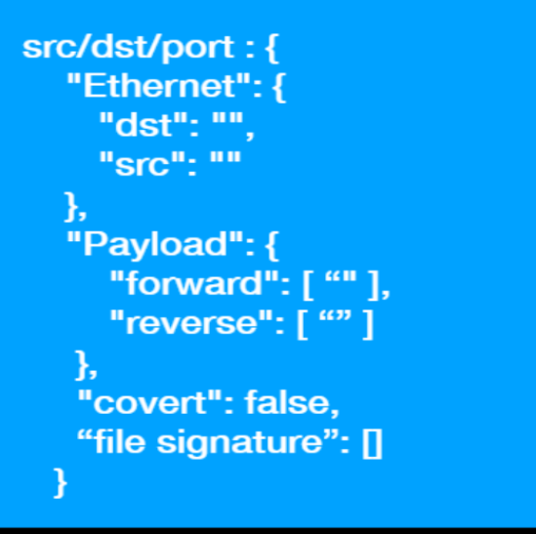

COMMUNICATION DETAILS:
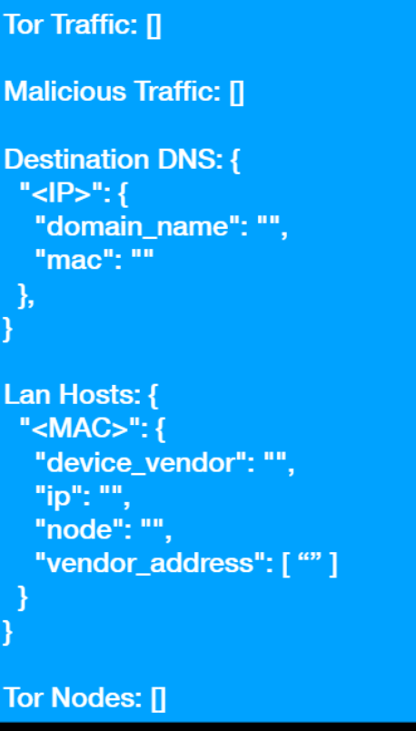

RESULT:
PcapXray quickly creates clear network diagrams from PCAP files, showing devices and suspicious traffic. It makes forensic analysis faster and easier for investigators.

